CSD340 | GitHub Repository Setup
Module 1 Assignment 1.2
Student: Zachary White
Professor: Sue Sampson
Date: June 5, 2026
Class: CSD340

GitHub Repository Link
Repository created and made public at:
https://github.com/DevZWhite/CSD340-306J-Web-Development-with-HTML-and-2267-DD-

Step 1: Initialize Git Repository
Assignment Instruction
Open a terminal and navigate to your local CSD directory. Run 'git init' to initialize a new empty Git repository in the project folder.

What I Did
I navigated to C:\CSD\CSD340 in the Windows Command Prompt and ran 'git init'. Git confirmed the creation of a new empty repository at C:/CSD/CSD340/.git/, setting up the hidden .git folder that tracks all version history going forward.
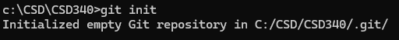

Step 2: Add GitHub Remote Origin
Assignment Instruction
Sign in to GitHub, click the green Code button on your repository, copy the HTTPS URL, and run 'git remote add origin <URL>' to connect your local repo to GitHub.
What I Did
I copied the HTTPS URL from my GitHub repository and ran 'git remote add origin' followed by the full URL. This linked my local C:\CSD\CSD340 folder to the remote GitHub repository, establishing 'origin' as the shorthand name for that remote connection.

Step 3: Pull from GitHub (git pull origin main)
Assignment Instruction
With the remote added, run 'git pull origin main' to download the repository contents including the README.md initialized on GitHub into your local directory.
What I Did
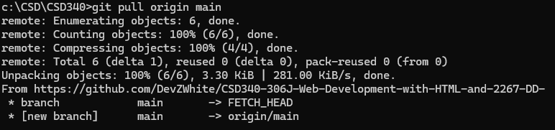
I ran 'git pull origin main' and Git fetched 6 objects from GitHub, unpacking 3.30 KiB of data at 281 KiB/s. The main branch was set up to track origin/main, and the README.md file created on GitHub was successfully pulled down into my local folder.

Step 4: Verify Local Directory (dir)
Assignment Instruction
After cloning/pulling, verify the repository contents locally. On Windows, run 'dir' in the terminal to list files and confirm the README.md is present.
What I Did
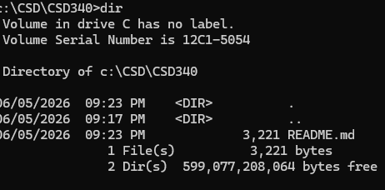
I ran 'dir' inside C:\CSD\CSD340 and confirmed the README.md file (3,221 bytes) was successfully downloaded. The directory listing showed 1 file and 2 directories, confirming the repository was properly set up locally with all files in place.
Step 5: GitHub Repository Landing Page
Assignment Instruction
Take a screenshot of your GitHub repository landing page showing the updated README.md with the h1 course title header, h2 Contributors section, and your name and instructor listed as bullet points.
What I Did
I updated the README.md with a full course overview including the HTML & CSS Fundamentals title, course description, learning objectives, module breakdown, and technologies used. The GitHub repository landing page now displays the fully rendered README, confirming all changes were successfully pushed to the remote repository.
